Baptistry - Preparing for a Baptism

The baptistry is comprised of three separate elements relating to baptisms: The water pump, the waterfall, and the water heater. It takes a few hours for the water to heat sufficiently for a baptism. If the baptism is scheduled for a morning, it is advisable to pre-heat the water the day before the baptism.

Note: The water heater will only heat water when the water pump is running.

* If the water pump is already running, and the heater is then turned on, the water will start being heated.
* If the water heater is already turned on, and the water pump then starts running, the water will start being heated.
* If the water pump and heater are both turned on, and either device is turned off, the water will stop being heated.

# Day Prior to a Baptism

* **Turn the Water Pump and Waterfall On** by activating the 8 HR mode on the On Demand Timer Switch. This will run both the Water Pump and the Waterfall for 8 hours, which should be enough time to heat the pool.
* **Turn on the Water Heater** located behind the baptistry wall.
  1. Press the “Spa Off” button on the Water Heater Control Panel. This will ensure the Water Heater Control Panel is in a reset state.
  2. Press the “Spa On” button on the Water Heater Control Panel.
  3. You should hear the heater blower turn on. Repeat steps 1-2 above if you do not hear anything.
  4. Adjust the temperature using the up and down arrow buttons. An optimal water temperature for a baptism is between 83 – 90° F, warmer for hotter days and cooler for colder days.

# Two Hours Prior to Baptism:

* **Turn the Water Pump and Waterfall On** utilizing the On Demand Timer Switch. Set the time as needed to have the baptism.
* **Turn the Water Heater** located behind the baptistry wall to “Spa On” if it is not already turned on.

# Just Prior to Baptism:

* **Note**: It doesn’t matter whether the waterfall is running during a baptism. If you do not want the waterfall to run during the baptism turn the pump/waterfall off by setting the On Demand Timer Switch to “Off” and setting the Baptistry Timer to “System Off”.

# Following the Baptism:

* Set the Baptistry Timer to “Run”.
* Set the On Demand Timer Switch to “Off”.
* Turn the Water Heater Control Panel to “Heater Off”.

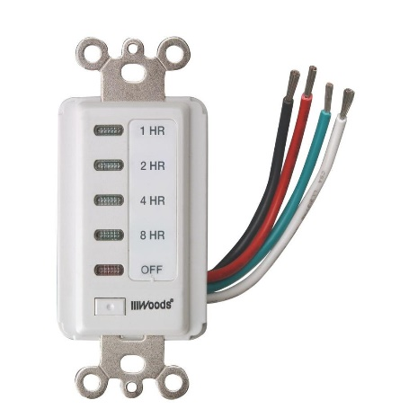

On Demand Timer Switch

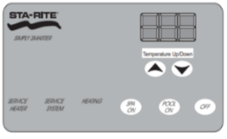

Water Heater Control Panel

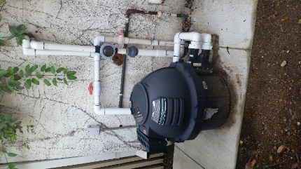

Water Heater

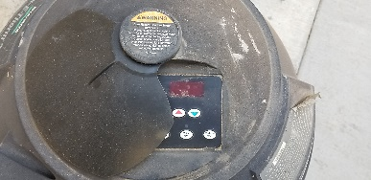

Water Heater Control Panel

Cover Plate

Baptistry Timer

