Node-200 Programming: Time and Date

1. Push the  button until the  icon is displayed.
2. All 4 digits will be displayed representing the year. Use the   or   buttons to change the year. Press the   button to proceed to setting the month.
3. All 4 digits will be displayed with the two digits on the left representing the month flashing. Use the   or   buttons to change the month. Press the   button to proceed to setting the day.
4. Only the two digits on the right side will be displayed and flashing, representing the day. Press the   or   button to change the day. Press the   button to proceed with changing the hour. Press the **right arrow (>)**button to proceed to setting the time.
5. The AM/PM/24 time setting is shown flashing. Press the   or   button to change the time setting to **AM**, **PM**, or **24-hour** time. Press the   button to proceed to setting the hour.
6. All 4 numbers are shown with the two numbers on the left flashing, representing the hour. Use the   or   buttons to change the hour. Press the   button to proceed to setting the minutes.
7. All 4 numbers are shown with the two numbers on the right flashing, representing the minutes. Use the   or   buttons to change the minutes. Pressing the   button will advance to the year setting at step **#2**.

Setting start Times

1. Press the  button until the  icon is displayed.
2. The start time will be displayed flashing, along with the program letter (A, B, or C) and the start time number (1, 2, 3, or 4) in the upper left of the display. Up to 4 different start times can be set for each program. In this mode the numbers do not represent stations, they represent the 4 start times per program. Only one start time is needed to initiate a program. Start times 2, 3, and 4 will repeat the program 2, 3, or 4 times each watering day.
3. Use the **plus (+)** or **minus (-)**buttons to change the start time for the program that is displayed. Each press of the button will change the start time in 15-minute increments.
4. Press the **right arrow (>)** button to add an additional start time to the program displayed. The start time number is shown in the upper left corner of the display.
5. Press the **PRG button** to add start times to a different program.
6. Press the  button to proceed to the next programming function or allow the controller to return to idle mode.

**Setting Station Run Times**

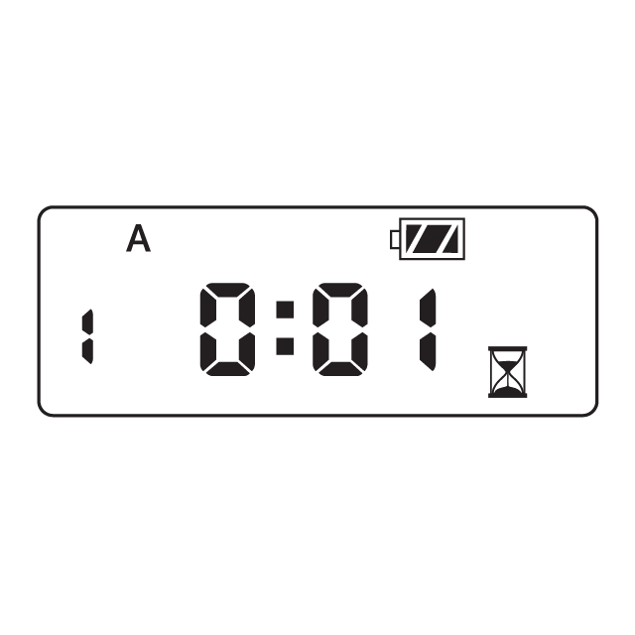

The **Station Run Times** mode allows you to enter a length of run time for each station assigned to a particular program ( A, B, or C). Each station that has a run time associated with a program will be activated and operate one after another sequentially with each start time for that program.

1. Press the  button until the  icon is displayed.
2. The run time will be displayed flashing. Also shown is the program letter (A, B, or C) and the active station # on the lower left side of the display. Press the plus or minus button to change the station run time from 1 minute to 6 hours.
3. Press the right right arrow button to advance to the next station.
4. Press the **PRG**button to add a run time to another program.
5. Press the  button to proceed to the next programming function or allow controller to return to idle mode.

**NOTE:**After programming the run time for the last station press the **right arrow (>)**button to display the total run time for the program.

**NODE - WHY DOES MY SYSTEM TURN ON AGAIN?**

A common reason for a controller to repeat a cycle is too many programmed start times. Only one start time per active program is required, a second start time will cycle the program an additional time.

**NOTE:** In the **Start Times** mode position, the numbers 1-4 do not represent stations. The numbers represent the program start times. Each program can start up to 4 times on the set days to water. One start time will activate all stations sequentially in that program. If you want the stations to operate one time in sequential order and then not repeat, set start times 2, 3, and 4 to OFF. Multiple start times in a program can be used for separate morning, afternoon, or evening watering cycles.

**Example:** Program A has four stations (1-4) assigned to it and the program has one start time at 5:30 AM. At 5:30 AM, station 1 will water, followed by station 2, then station 3, and so on until all four stations have watered. Start times should appear as you see in the chart below:

|  |  |  |  |
| --- | --- | --- | --- |
| **Start  Times** | **PROGRAM A** | **PROGRAM B** | **PROGRAM C** |
| **1** | 5:30 AM | OFF | OFF |
| **2** | OFF | OFF | OFF |
| **3** | OFF | OFF | OFF |
| **4** | OFF | OFF | OFF |

Individual stations are assigned to a program (A,B,C). Each program requires only one start time to initiate a watering sequence of all the stations assigned to that program. Start times are assigned to programs, not stations. The controller will operate the stations in numerical order. When a station has completed its watering time, the controller will switch to the next station in that program automatically.

**Setting Watering Days**

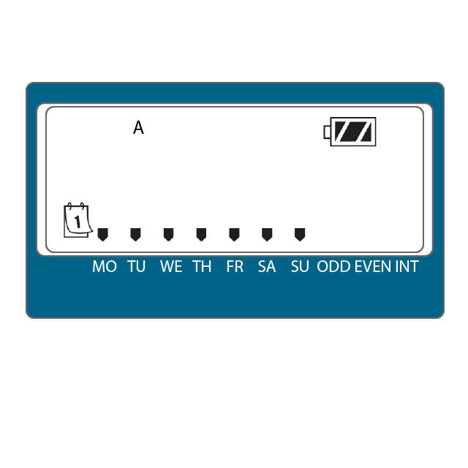

1. Press the  button until the  icon is displayed.
2. The program letter (A, B, or C) will be displayed.
3. Arrows point at the specific days of the week in which watering will occur. Press the **plus (+)** or **minus (-)** buttons to scroll though the days.
4. Press the **plus (+)**button to activate that day for the program displayed, or the **minus (-)**button to cancel watering for that day. **The arrow will show on the watering days for the active program.**
5. Press the **PRG button** to set days to water for a different program, if desired.
6. Press the  button to proceed to the next programming function or allow controller to return to idle mode.